TPAR for IT Services
If the business is providing information technology (IT) services, then a lodgement of Taxable Payments Annual Report (TPAR) will be required if all the following conditions are met:
- The business provides IT services to other people and businesses.
- The business paid contractors or subcontractors to provide these IT services on behalf of the business.
- The business has an Australian Business Number (ABN).
Payments made to employees are not to be reported in the TPAR.
This came into effect from the 2019/2020 financial year.

What are IT Services?
IT services include the provision of expertise about information technology. This includes services conducted both onsite and online. It is inclusive of services that provide support or modification of hardware or software.
Just using IT hardware or software in your business to provide a service (unless it is an IT-specific service), does not make it part of an IT service, for example, using accounting software to provide bookkeeping services.
Examples of some IT services include:
- Computer facilities management.
- Computer hardware consulting.
- Computer network systems design and integration.
- Computer programming.
- Computer software consulting.
- Internet and web design consulting.
- IT consulting.
- Customised software development.
- Software installation.
- Software simulation and testing.
- Systems analysis.
- Technical support.
Examples of activities that are not IT services:
- Using IT software or hardware in your business to provide a service (other than an IT service).
- Mass-producing computer software. For example, reproduction of recorded media.
- Leasing or hiring out of computers or other data processing equipment.
- Providing data processing services or computer data storage and retrieval services.
- Installing computer cables.

ATO Examples

1. Manufacturing and software development for storage devices
Compass Drives Pty Ltd has an ABN and manufactures USB drives and hard drives. Compass sells the USB drives to retail stores, which then sell them to consumers. The manufacture and supply of computer hardware and peripherals for consumers is not a supply of an IT service. Compass Drives therefore does not have to lodge a TPAR.
Compass Drives also engages contractors to write USB drive optimisation software, which Compass Drives then sells separately via its website and bundles it with its high-end products. The software being sold by Compass Drives is sold as a product rather than a service. It is not designed in response to, or for the needs of a client, therefore Compass Drives is not supplying an IT service when it develops or engages contractors to develop this software. Compass Drives is not required to submit a TPAR.

2. Network Design, Installation and Support
Whiz Networking Pty Ltd has an ABN and provides IT services. They use contractors to install and test the network hardware; develop, install and test the intranet, and provide ongoing technical support. The services the business provides to its clients makes up 40% (therefore more than 10%) of its business income. Whiz Networking must therefore report, in a TPAR, the payments made to contractors for these IT services.
Whiz Networking also contracts a company to provide network hardware to its clients on its behalf. The supply of the hardware is not considered to be ‘providing an IT service’, therefore Whiz Networking is not required to report payments it makes to this company.

3. IT Company using both Employees and Contractors.
Goodtime Software Pty Ltd has an ABN and develops accounting software for clients. An accounting firm engages Goodtime Software to write an accounting software suite that is tailored to the specific needs of the firm. Goodtime Software develops this suite for the accounting firm and provides ongoing software patches to rectify bugs as they are discovered. Goodtime Software has employees to develop the accounting software and uses contractors to write patches as required. Goodtime Software is required to lodge a TPAR to report payments it makes to its contractors as they are providing an IT service on its behalf (unless a reporting exemption applies).

When IT and Other Services are Provided
If IT services are only part of what the business provides, a TPAR may still be required.
A TPAR must be lodged if the total payments received for IT services are:
- 10% or more of the gross business income.
A business may choose to lodge a TPAR when:
- Under the 10% threshold.
- The business is unsure that they will be under the threshold.
Each year a business must:
- Review if a TPAR needs to be lodged.
- Report these payments to the ATO on the TPAR by 28 August.

Engaging Overseas Contractors
Payments to overseas contractors engaged to provide IT services on behalf of a business providing IT services, need to be reported in the TPAR.
Contractors can be located outside of Australia and may not have an ABN, however there is no exclusion based on the location or tax residency of the payee.
If an ABN is not provided, a PAYG withholding amount may need to be withheld.

Details You Need to Report
The details you need to report for each contractor include:
- Name (business name or individual’s name).
- Address.
- ABN, if known. If a contractor’s ABN has changed during the year, include each ABN for that contractor - (new supplier record/card for new ABN).
- Total amounts for the financial year of:
  - Gross amount (including GST) paid and any tax withheld.
  - Total GST paid.
  - Total tax withheld when an ABN was not quoted.

Lodgement of TPAR
Lodgements are due by 28 August.
Tax agents and BAS agents can advise, prepare, and lodge the TPAR. Business owners can also prepare and lodge the report directly. A bookkeeper can assist the owner to prepare the report but may not lodge the report directly.
To meet reporting obligations, use one of the following methods that work for the business’ situation:
- Sole traders and businesses:
  - Use business software if it is SBR-enabled.
  - Create a TPAR data file in business software and lodge through Online Services for Business (OSfB) using the file transfer function.
  - If you do not have business software, use OSfB, select ‘Lodgements’, then ‘Taxable payments annual report’.
- Tax professionals Tax and BAS Agents:
  - Use business software if it is SBR-enabled.
  - Create a TPAR file in business software and lodge through Online Services for Agents (OSfA) using the file transfer function.
  - If you do not have business software, use OSfA, select ‘Lodgements’, then ‘Taxable payments annual report’.
- Paper form:
  - Sole traders and businesses can order a paper form online through the ATO publications ordering service: Taxable payments annual report (NAT 74109).
Note that the ATO cannot process TPAR forms that are:
    - Photocopies of the form.
    - Scanned images of forms (.jpg, .tif).
    - Spreadsheets (.xls, .xlsx).
    - Word processing files (.doc, .docx, .pdf, .otf).
  - Completed forms may be mailed to ATO, PO Box 3128, Penrith NSW 2740.
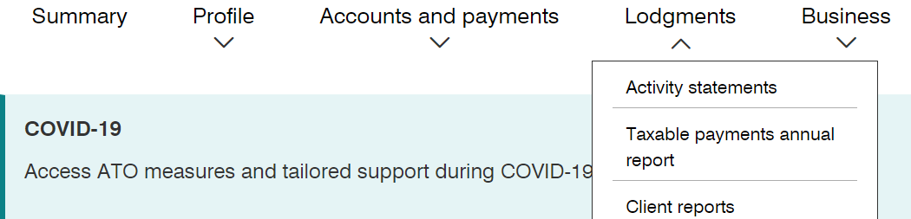

TPAR Non-lodgement Advice
If it’s been worked out that there is no TPAR to lodge, a non-lodgement advice form should be submitted to the ATO. This form:
- Allows notification of multiple years on the same form.
- Allows business to advise when they do not need to lodge in the future.
- Allows a reason for not lodging.
- Validates information entered.
- Provides a reference number for confirmation.
- Appears in the lodgement history tab.
