# ICB Quality Management System

For BAS Agents and Bookkeepers

Draft 15 July 2024

# Concept

Specifically developed from existing resources to assist adherence to the TASA2009 and the Tax Agent Services (Code of Conduct) determination 2024

ICB resources can be accessed by Members. You will need to be logged into the website. The resources are hyperlinked in the below.

This document provides access to the current material to assist you to know and comply with the requirement to have policies, procedures and systems to meet your Professional and Code of Conduct requirements.

The objective of this system: to provide confidence that you are compliant with the Code of Conduct:

“The extent of internal controls in place will differ significantly between tax practitioners based on the size of individual practices, the level of day-to-day engagement by a tax practitioner on the tax agent services being provided, and the complexity of the services being provided as well as the complexity of the clients’ tax affairs.” (Explanatory Statement (ES) Section 40)

* regular training of new and existing staff on their obligations under the Act when providing tax agent services whether or not as a registered tax practitioner;
* the use of information barriers where there is a conflict of interest between current and former clients;
* quality assurance processes and systems to review the accuracy and standard of services being provided to clients;
* authorisation and risk management processes considering potential conflicts of interest prior to accepting new clients;
* file management system with access controls, limiting the users able to access confidential information;
* documented reporting lines and responsibilities to ensure staff duties are effectively segregated and prevent the incidence of fraud or non-compliance; or
* independent internal control reviews.

# Contents

ICB Quality Management System 1

Concept 1

Contents 1

Being Professional 2

Complying with the (TASA) Code 3

Specifically addressing the new code obligations 3

Existing Code Obligations 4

Technical Knowledge Base 5

Your Practice Controls 6

Client Engagement 7

Working with the Client 7

Authority to Make Payments 7

Business Compliance Basics 8

Data Integrity 8

End of Year Processes 8

HR Advice – acting as an HR Intermediary 8

Single Touch Payroll 8

Interacting with the Tax Office 8

Adhering to the Code of Conduct 8

Training and CPE 8

Supervision and Control 8

Advanced thinking and development 9

## Being Professional

Each firm should have statements as to its culture and its intentions as to how it is perceived and wishes to behave:

The Professional Bookkeeper

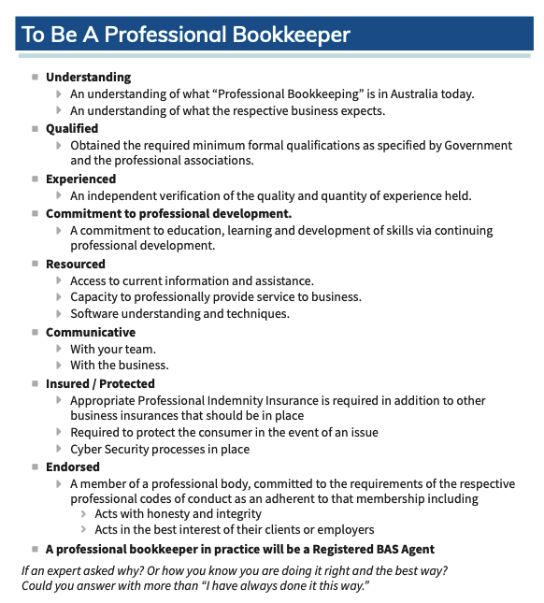

Link to explaining the Professional Bookkeeper to be provided soon

## Complying with the (TASA) Code

Refer to a subsequent Section titled “Adhering to the Code of Conduct” which provides guidance on other aspects of being a professional Bookkeeper which contribute to your adherence with the Code requirements.

### Specifically addressing the new code obligations

Upholding and Promoting the ethical standards of the tax profession

* Disclosure Statement?

Checklist of things to have in place

* Training on Code
* Process underperformance
* Mechanism for reporting
* Protect reporters
* Direct – not breach the code
* Record “potential” breaches
* Process to amend false or misleading
* Police Checks
* Recruit Process – (dereg)
* Reward compliance with Code
* Culture – transparency etc

False or misleading statements

* When you discover a mistake what must you do
* [Authority to make statements](https://www.icb.org.au/s/Resources/Authority-to-Lodge)
* [Considering Materiality](https://www.icb.org.au/s/Resources/Materiality-Decisions)

Dealings with Government. (immaterial for our audience at this time)

* Conflicts of Interest
* Confidentiality

Keeping of proper client records

* [Keep your own proof](https://www.icb.org.au/s/Resources/Keep-Your-Own-Proof)
* [Bookkeepers Task Report](https://www.icb.org.au/s/Resources/Bookkeepers-Task-Report) – Keep records to prove the basis for what you did
* [Checklist of Information for Accountants](https://www.icb.org.au/s/Resources/Checklist-Information-for-Accountants) – Now you should specifically keep copies
* [Business record Keeping requirements](https://www.icb.org.au/s/Resources/Business-Record-Keeping-Obligations)
* [Are your clients keeping Good Records?](https://www.icb.org.au/s/Resources/Are-Your-Clients-Keeping-Good-Records)

Ensuring ..services provided on your behalf are provided competently

* [ICB Explains “Competence”](https://www.icb.org.au/s/Resources/TPB-Code-of-Conduct-Competence)

Quality Management System

Keeping your clients informed of all matters

* Client Contingency Plans – what if something happens
  + [TPB provides Guidance](https://www.tpb.gov.au/incapacity-tax-practitioner) & the plan
* ICB Template – [Your Engagement Letter](https://www.icb.org.au/s/Resources/Engagement-Letter)
* Disclosure Statement. Needs link

### Existing Code Obligations

ICB Definitive Guide – Applying the Code of Conduct

This resource produced at the implementation of the TASA2009 regime still applies in processes to think about Client engagements and applying the Code of Conduct. (Ignore the page

Can you do the work?

* ICB Explains - [Review your professional and ethical considerations](https://www.icb.org.au/s/Resources/Review-Professional-and-Ethical-Considerations)
  + Do you have the skills and competency
  + Do you have a conflict of interest?
  + Is your honesty and integrity being upheld?

**Honesty and integrity**

1. You must act honestly and with integrity.
2. You must comply with the taxation laws in the conduct of your personal affairs.
3. If you:
   * receive money or other property from or on behalf of a client, and
   * hold the money or other property on trust

you must account to your client for the money or other property.

**Independence**

1. You must act lawfully in the best interests of your client.
2. You must have in place adequate arrangements for the management of conflicts of interest that may arise in relation to the activities that you undertake in the capacity of a registered tax agent.

**Confidentiality**

1. Unless you have a legal duty to do so, you must not disclose any information relating to a client’s affairs to a third party without your client’s permission.
   * ICB Explains – [BAS Agents and Confidentiality](https://www.icb.org.au/s/Resources/Breach-of-Confidentiality)
   * TPB Information – [Confidentiality of Client Informatiom](https://www.tpb.gov.au/confidentiality-client-information-information-sheet-tpbi-212014)

**Competence**

1. You must ensure that a tax agent service that you provide, or that is provided on your behalf, is provided competently.  
   - ICB Explains - [Competence](https://www.icb.org.au/s/Resources/TPB-Code-of-Conduct-Competence)
2. You must maintain knowledge and skills relevant to the tax agent services that you provide.
3. You must take reasonable care in ascertaining a client’s state of affairs, to the extent that ascertaining the state of those affairs is relevant to a statement you are making or a thing you are doing on behalf of a client.
4. You must take reasonable care to ensure that taxation laws are applied correctly to the circumstances in relation to which you are providing advice to a client.

**Other responsibilities**

ICB Explains - [“Other Responsibilities”](https://www.icb.org.au/s/Resources/BAS-Agent-Obligations)

1. You must not knowingly obstruct the proper administration of the taxation laws.
2. You must advise your client of the client’s rights and obligations under the taxation laws that are materially related to the tax agent services you provide.
3. You must maintain the professional indemnity insurance that the Board requires you to maintain.
4. You must respond to requests and directions from the Board in a timely, responsible and reasonable manner.
5. You must not employ, or use the services of, an entity to provide tax agent services on your behalf if:
   1. you know, or ought reasonably to know, that the entity is a disqualified entity; and
   2. the Board has not given you approval under section 45-5 to employ or use the services of, the disqualified entity to provide tax agent services on your behalf.
6. You must not provide tax agent services in connection with an arrangement with an entity that you know, or ought reasonably to know, is a disqualified entity.
7. You must comply with any obligations determined under section 30-12.

To assist you to comply with certain aspects of the Code TPB have provided guidance material on matters such as:

* [Enhancing client verification process for tax practitioners](https://www.tpb.gov.au/client-verification-process-tax-practitioners)
* [Acting lawfully in the best interests of clients](https://www.tpb.gov.au/acting-lawfully-best-interests-clients)
* [Letters of engagement](https://www.tpb.gov.au/letters-engagement)
* [Holding money or other property on trust](https://www.tpb.gov.au/holding-money-or-other-property-trust)
* [Reasonable care](https://www.tpb.gov.au/reasonable-care)
* [Managing conflicts of interest](https://www.tpb.gov.au/managing-conflicts-interest)
* [Confidentiality of client information](https://www.tpb.gov.au/confidentiality-client-information).
* [Code obligations when you employ, use or have an arrangement with a disqualified entity](https://www.tpb.gov.au/code-obligations-when-you-employ-use-or-have-arrangement-disqualified-entity)

For a detailed explanation of various Code categories, refer to [TPB(EP) 01/2010 Code of Professional Conduct](https://www.tpb.gov.au/explanatory-paper-tpbep-012010-code-professional-conduct).

## Technical Knowledge Base

Your ICB Resource Categories – [Website link](https://www.icb.org.au/s/Resource-Categories)

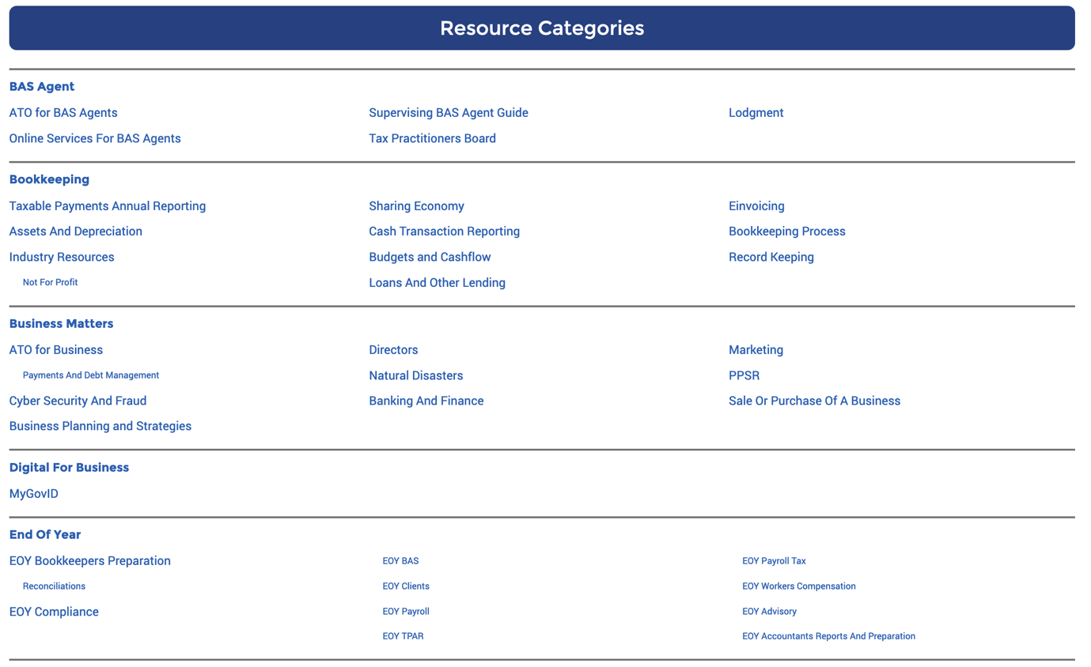

## Your Practice Controls

* Governance & Leadership
* Monitoring Performance
* Adherence to the code
* Client engagement
* Keeping records
* Confidentiality
* Management of conflicts
* Recruitment
* Training
* Management

### Client Engagement

Client Verification / Identity Checks

* [ICB Explains the requirement](https://www.icb.org.au/s/Resources/Identity-of-Your-Clients--Check-and-Prove)
* Scantek – Digitised Solution

Can you do the work?

* ICB Explains - [Review your professional and ethical considerations](https://www.icb.org.au/s/Resources/Review-Professional-and-Ethical-Considerations)
  + Do you have the skills and competency
  + Do you have a conflict of interest?
  + Is your honesty and integrity being upheld?

Cyber Security

* [ACSC guide for Agents](https://www.icb.org.au/s/Resources/Agents-Cyber-Security-is-Expected)

Data Breach

* [ICB Introduction and links](https://www.icb.org.au/s/Resources/Agents-and-Notifiable-Data-Breaches)

Materiality Decisions

* ICB Explains the concept of: [making materiality judgements](https://www.icb.org.au/s/Resources/Materiality-Decisions)

Record keeping

* [Are your clients keeping good records?](https://www.icb.org.au/s/Resources/Are-Your-Clients-Keeping-Good-Records)
* [Business Record Keeping Obligations](https://www.icb.org.au/s/Resources/Business-Record-Keeping-Obligations)
* [ATO – Overview of record Keeping](https://www.ato.gov.au/businesses-and-organisations/preparing-lodging-and-paying/record-keeping-for-business/overview-of-record-keeping-rules-for-business)
* [Record Keeping Checklist](-%09https:/www.icb.org.au/s/Resources/Record-Keeping-Checklist)

Strategy Guide

* [Proactively designing what your practice is going to be](https://www.icb.org.au/s/Resources/Strategy-Guide-for-Members)

Security and Privacy

• [ICB – Security and Privacy](https://www.icb.org.au/s/Resources/Security-and-Privacy)

• [ICB – Staying Smart and Secure Online](https://www.icb.org.au/s/Resources/Staying-Smart-and-Secure-Online)

• [ICB – Security of Client Information](https://www.icb.org.au/s/BAS-and-BAS-Agents/BAS-Agent-Code-of-Conduct/Security-of-Client-Information)

• [ICB – Clarification Around Storing TFN Numbers](https://www.icb.org.au/s/Resources/Clarification-around-storing-TFN-numbers)

• [ICB – Privacy](https://www.icb.org.au/s/Resources/Privacy)

• [ICB – Electronic Document Storage](https://www.icb.org.au/s/Resources/Electronic-Document-Storage)

• [ICB – Software Terms and Conditions](https://www.icb.org.au/s/Resources/Terms-and-Conditions---Backup-of-Data)

• [ICB – Emergency Plans and Disaster Recovery](https://www.icb.org.au/s/Resources/Emergency-plans---Worksafe-Requirement)

## Working with the Client

### Authority to Make Payments

Before any external bookkeeper makes payments on behalf of a client they must obtain authority from the client

ICB Explains – [Authority to Make Payments](https://www.icb.org.au/s/Resources/Authority-to-Make-Payments)

### Business Compliance Basics

ICB Explains – [the compliance checklist](https://www.icb.org.au/s/Resources/Business-Compliance-Basics)

### Data Integrity

ICB Explains – [is the bookkeeping data correct](https://www.icb.org.au/s/Resources/Data-Integrity-Guide)

### End of Year Processes

[Project Plan – prepare for end of year](https://www.icb.org.au/s/Resources/Bookkeeper-EOY-Project-Plan)

### HR Advice – acting as an HR Intermediary

ICB explains – [Bookkeepers providing HR Advice](https://www.icb.org.au/s/Resources/HR-Intermediary)

### Single Touch Payroll

ICB explains – [Authorisations and Declarations in STP](https://www.icb.org.au/s/Resources/STP-Authorisations-Declarations)

## Interacting with the Tax Office

ICB Explain - [Authority to Lodge](https://www.icb.org.au/s/Resources/Authority-to-Lodge)

Includes the records that must be kept

## Adhering to the Code of Conduct

### Training and CPE

* [ICB explains CPE & the TPBs requirements](https://www.icb.org.au/s/Resources/CPE-Plan-for-BAS-Tax-Agents)

### Supervision and Control

For any registered Agent who either employs another person or engages with another entity to provide services on their behalf

* [ICB Explains](https://www.icb.org.au/s/Resources/BAS-Agents-Sufficient-Supervision) > “Supervision & Control”
* [TPB Explains](https://www.tpb.gov.au/supervision-and-control-bas-agents)
* [TPB Information Sheet 36/2021](https://www.tpb.gov.au/tpbi-362021-supervisory-arrangements-under-tax-agent-services-act-2009)

If you are mentoring or supervising another Agent – guidelines for actions

* [ICB explains Supervising BAS Agent Guidelines](https://www.icb.org.au/s/Resources/Supervising-BAS-Agent-Guidelines)

## Advanced thinking and development

The Accounting Professional & Ethical Standards Board have issued “Quality Management for Firms that provide non-Assurance Services”

APES 320

Available here. <https://apesb.org.au/standards-guidance/quality-control-for-firms-apes-320/>

For multi-person practices we recommend review of the Systems and recommendations contained therein.